# Practical Exam – Shopping List

You have been tasked to create a simple application that simulates a Shopping List. The application should hold **products**, which are the main app **entities**. The app is called ShoppingList.

The functionality of the application should support **creating**, **listing**, **editing** products.

The application should **persist** the data into a **database**.

## Overview

Your application should be built on **each one** of the **following technologies**:

### PHP

* **Symfony** framework
* **Twig** view engine
* **Doctrine** ORM
* **MySQL** database

### JavaScript

* **NodeJS** + **ExpressJS** frameworks
* **Handlebars.js** view engine
* **Sequelize ORM**
* **MySQL** database

### Java

* **Spring** framework (**Spring MVC** + **Spring Boot** + **Spring Data**)
* **Thymeleaf** view engine
* **JPA** / **Hibernate ORM** + **Spring Data** data access
* **MySQL** database

### C#

* **ASP.NET** framework (**ASP.NET MVC** + **Entity Framework Core**)
* **Razor** view engine
* **Entity Framework Core** ORM
* **MySQL** database

## Data Model

The Product entity holds **5 properties**:

* id – technology-dependent identifier (ObjectID for JavaScript, int for all other technologies)
* priority – non-null integer
* name – non-empty text
* quantity – non-null integer
* status – non-empty text (will either be “bought” or “not bought”).

## Project Skeletons

You will be given the applications’ skeletons, which holds about **90%** of the logic. You’ll be given some **files** (**controllers**, **models** etc.). The files will have **partially implemented logic**, so you’ll need to write some code for the application to **function properly**.

The application’s views will be given to you fully implemented. You only need to include them in your business logic.

**Each technology** will have its **own skeleton**, and the **different** **skeletons** may **differ** in **terms** of **what is given to you** and **what is to be implemented**.

Everything that has been given to you inside the skeleton is **correctly implemented** and if you write your code **correctly**, the application should work just fine. You are free to change anything in the Skeleton on your account.

## User Interface

This is the user interface or how the application’s pages should look in their final form (fully implemented). You have several pages, described below:

### Index Page

#### Route: **“/”**

Displays **all** the **products** from the database with **an option** to **modify** them.

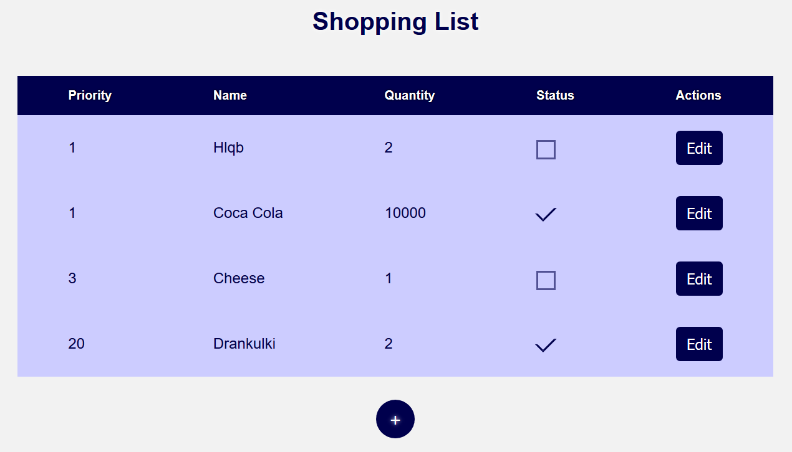

### Create Page

#### Route: **“/create”**

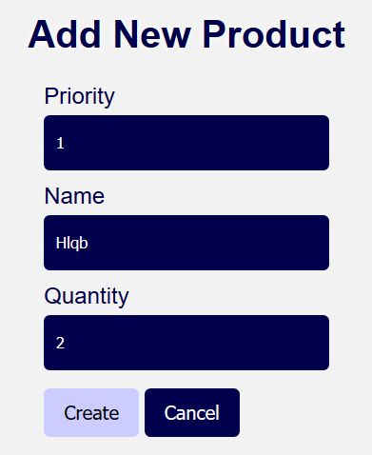

### Edit Page

#### Route: **“/edit/{id}”**

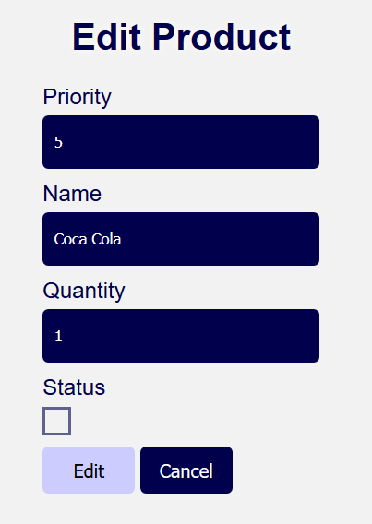 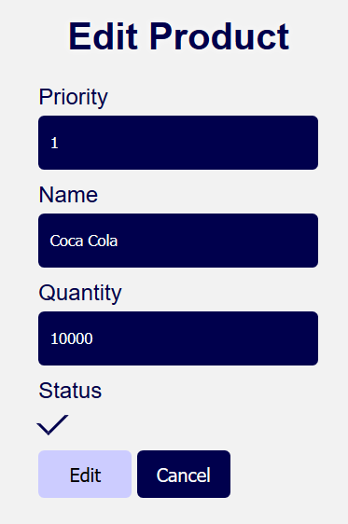

## Problem

As you can see the different pages are on different routes. Most of the routing logic will be given to you in the **Skeleton**, but you should make sure that the application **works properly**.

Implement the “**ShoppingList” app** using all the above described **4 technologies**.